**L**

**ABS**



**Offer Letter of Internship**

# Dear Atharva,

Welcome on board to **FT42 Internship Program!**

Further to the workshop, interview, and discussions you have had with us, it is our pleasure to extend the following offer of internship to you at **FORTYTWO42 TECHNOLOGY INNOVATIONS PVT. LTD (OFFICE NO: 201, FLOOR NO.:2, SIDHH ICON SR No.1/1A/29/1& 2, BANER ROAD**

# PUNE MH 411045 IN)

Our goal is for you to learn and grasp our business and our processes, i.e., to develop innovative cutting-edge technologies and products, to create new technology driven business ventures and to provide ancillary research, development, and consulting services.

As we discussed, your internship is expected to last for 5 months starting **2nd January 2023** however, at the sole discretion of the Company, the duration of the internship may be extended or shortened from a case-to-case basis, based on the performance of select intern and/or interns.

During your internship, you may have access to confidential, proprietary, and/or trade secret information belonging to the Company. You agree that you will keep all this information strictly confidential as per the NDA signed and refrain from using it for your own purposes or from disclosing it to anyone outside the Company. In addition, you agree that, upon conclusion of the internship, you will immediately return all the property, equipment, and documents, including electronically stored information to the Company. By accepting this internship offer, you agree that you will follow all the Company's policies.

This letter constitutes the complete understanding between you and the Company regarding your internship and supersedes all prior discussions or agreements. This letter may only be modified by a written agreement signed by both of us.

Please indicate your acceptance of this offer by signing below and returning it to us. I hope that your internship with our company will be successful and rewarding.

**NAME: DNYANDA YANDE** **HR MANAGER, FORTYTWO LABS.**

SIGNATURE: _______________________________________

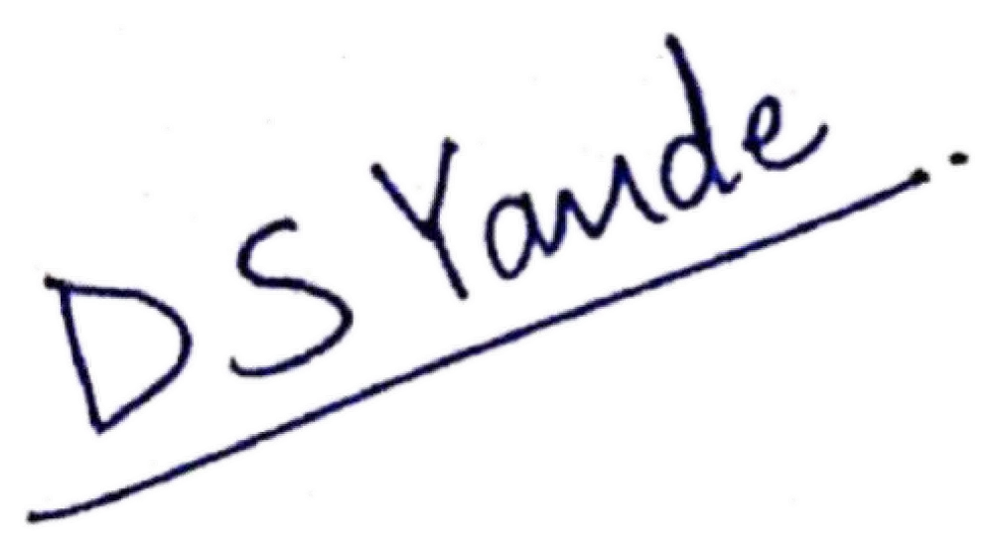

DATE: 27th October 2022

…………………………………………………………………………………………………………………………………………………

.

# INTERN NAME: Atharva Tilak

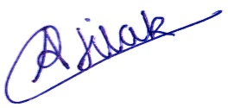

SIGNATURE: _________________________________________

DATE: 27th October 2022

**___________________________________________________________________________________ FORTYTWO42 TECHNOLOGY INNOVATIONS PVT.LTD.**

**(Registered Address)** **Office No: 201, Floor No:2, Siddh Icon Sr, No.1/1A/29/1& 2, Baner road Pune**

**MH 411045 INDIA. Email:**  **info@fortytwo42.in**